LAB TEST-01

AI ASSISTED CODIND

HT.NO:2403A53056

1.Create a Python function that converts an amount from one currency to another using exchange rates stored in a dictionary. Use GitHub Copilot along with VS Code. Use Few shot prompting.

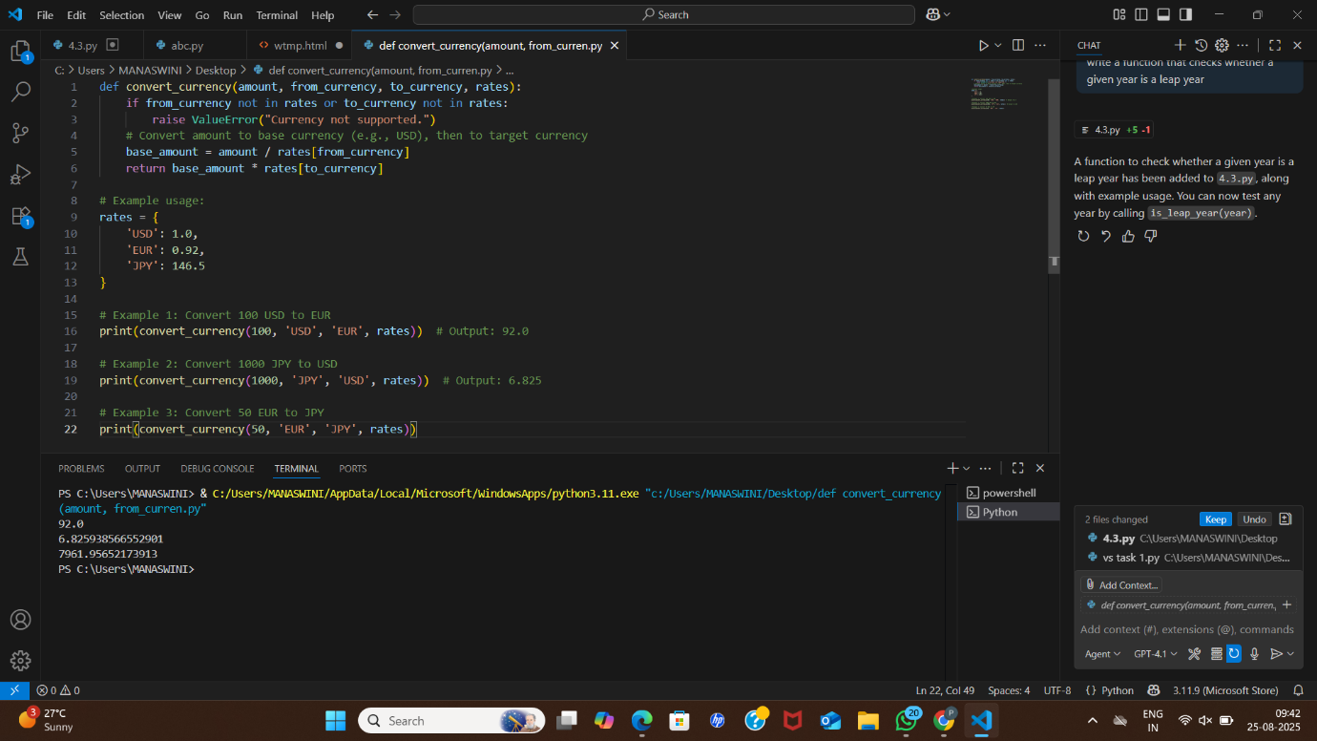

2.Write a Python program to extract all email addresses from a block of text using regular expressions. GitHub Copilot along with VS Code. Use zero shot prompting.

